INSTRUCTIONS FOR extended abstracts for   
Clean Air Conference 2024

Jack Smith1 and Brian E. Jones2

1 2 Thomastown Rd, Christchurch, 8543, New Zealand

2 CRAS Systems, Bishopdale, Christchurch, 8543, New Zealand

*Keywords*: list up to 10 keywords.

# General Format

2-page extended abstracts must not exceed 2 pages. A4 (297 × 210 mm) paper should be used with the following margins. Margins should be as follows: top 20 mm; bottom 20 mm; sides 20 mm; space between columns 8 mm.

Text should be in two columns, as shown in this example. The title should be 16 pt Arial font, all capitals, centred (Title style). Below this should be authors’ names as 12 pt Arial, sentence case, spaced 2.5 mm (or 7 pt) beneath the title (Author style), and author affiliations and addresses as 9 pt Arial (Author address style).

The main body text should be 10 pt Arial, justified, spacing of 3 pts after each paragraph (Normal style). Each line should be fully justified, hyphenating if necessary. Insert only a single space after a sentence. Avoid hyphens at the ends of two or more consecutive lines. Avoid widows and orphans.

Any required section headings are to be 12 pt Arial bold, numbered (with hanging indent), sentence case, left justified. (Stored as Heading 1 style in the MS Word document). 14 pt space above and 3 pt space below.

Use SI units wherever appropriate. Use slashes as in ‘m/s’ rather than ‘ms-1’ except where confusion may arise.

# Tables and Figures

Figures or images should be inserted using the Insert-Picture option in Word. This will fit them to the width of the column and in line with the text. This avoids the problem of floating images. Figures are generally best saved as .png files and images as .jpg files before inserting them. A maximum image width of 1000 pixels for the saved png/jpg files is generally more than adequate for this conference paper format.

Figures and Tables should fit in a single column, as below with a spacing of 12 before and 10 below the figure or table (Figure style). All Figures or tables should be referred to in the text, as in the case of this reference to Figure 1.

A numbered caption in 10 pt roman type should be placed below each figure, and above each table, with paragraph spacing of 12 points after the caption (use caption style), as in the example below. Captions should be concise, leaving full explanation to the text. The width of text should be at least 10 mm narrower than the full column. Captions with more than two lines usually look better as justified text rather than centred.

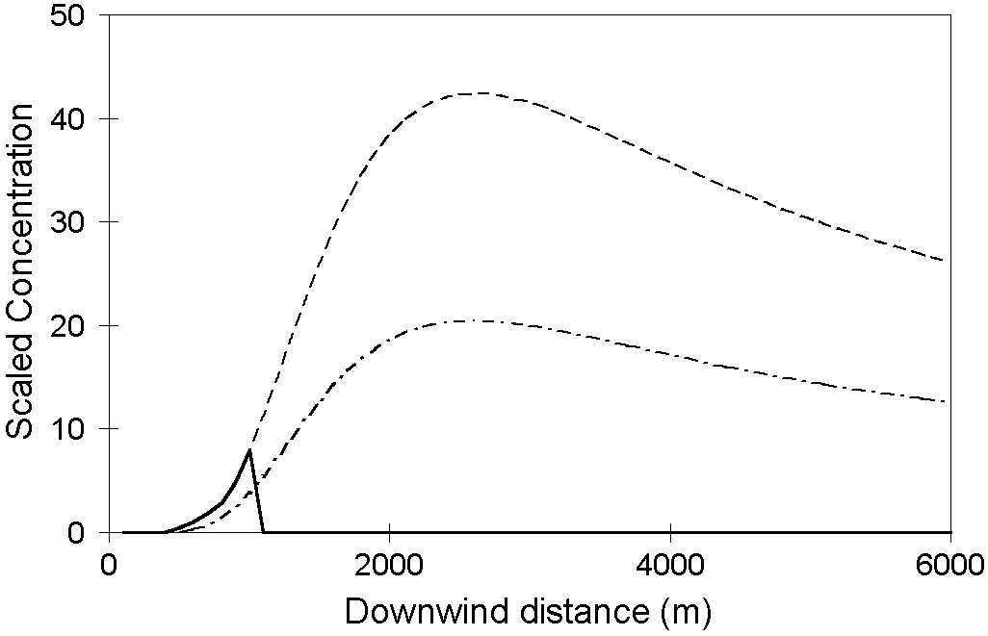

Figure 1. Example illustration (Caption style).

References

References should be made in the style (Baker 1995), or (Kuschel & Foster 1996) and (Baker 1995; Milligan *et al* 1986). These should be arranged alphabetically, and be restricted to no more than ten. Acknowledgments follow the list of references.

Baker R. 1995, ‘Risk management and risk assessment in air quality standards setting’, *Clean Air (Aust.)* **25**:62-7*.*

Kuschel G. and Foster E. 1996, ‘The Christchurch emissions inventory as an air quality management tool’, *Proceedings of the 13th International Clean Air and Environment Conference, Adelaide, 1996*, Clean Air Society of Australia & New Zealand, Eastwood, NSW, Australia, pp. 180-185.

This work was supported by the Foundation for Research Science and Technology under grant 04/0895.

# Licence to Use Copyright

By submitting a paper or extended abstract for presentation at the International Clean Air and Environment Conference, as author, you grant the following license to the Clean Air Society of Australia and New Zealand (CASANZ). As author you retain copyright of the paper, in addition to the moral rights as entitled as author of the material. In consideration for the publication of the paper the author grants CASANZ a non-exclusive right to: publish, reproduce, distribute, display and store the abstract in all forms, formats and media now known or as developed in the future, including print, electronic and digital forms. This includes the 26th International Clean Air and Environment Conference Proceedings which is an ISBN identified publication.

The author warrants that the paper is original work and does not infringe the intellectual property rights of any other person or entity and cannot be construed as plagiarising any other published work and that the paper has not been published previously.

If the research and/or presentation was prepared jointly with other authors, it is warranted that the author has been authorised by all co-authors to accept on their behalf, and to agree on their behalf the order of names in the publication of the abstract.

The paper contains no statement that is abusive, defamatory, libellous, obscene, fraudulent, nor in any way infringes the rights of others, nor is in any other way unlawful or in violation of applicable laws.

To view the full License to Use Copyright Policy, visit the CASANZ website.

Acknowledgments

Acknowledgment by the author of the use of material from an outside source is a condition of such use, as well as a courtesy. Wherever possible, it should be made not only in the acknowledgments section but also at the place or places in the text where the material is included.